

**KIE4024**

Optimization methods

**Name:** Omnia Ahmed Aly Diaa Mohammed Sarhan

**Matric Number:** KIE170715

**ID Number:** 17188912/1

**Group**: 1

**Assignment**

For this assignment, students must use MATLAB and Algebraic Mathematical programming Language (AMPL).

Given the cancer chemotherapy problem below:

$$\frac{dE}{dt}=s-μE+p\frac{ET}{h+T}-mET-K_{E}ME$$

$$\frac{dT}{dt}=rT\left(1-bT\right)-a\frac{ET}{T+g}-K_{T}MT$$

$$\frac{dM}{dt}=-γM+V_{M}\left(t\right)$$

where,

$\frac{dE}{dt}$ = Effector cells in patient’s body over time

$\frac{dT}{dt}$ =Tumour cells in patient’s body over time

$\frac{dM}{dt}$ = Drug concentration in patient’s body over time

Other details of the model such as parameter values can be obtained in Dynamics of a Mathematical model of Cancer cells with Chemotherapy, D Lestari *et al* 2019 *J. Phys.: Conf. Ser.* **1320** 012026

Minimize the chemotheraphy, Vm(t) and tumor, T(t) between t=0 and t=tf  for the minimization problem stated below:

$$Min J= \int_{0}^{tf}{(V_{m}\left(t\right)dt +\frac{T\left(t\right)}{T0})dt}$$

PART A

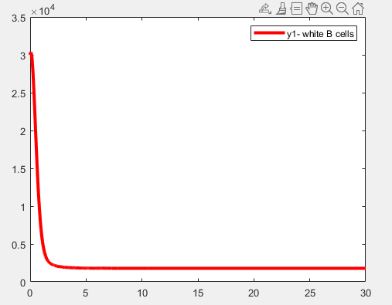

Figure A: Effector Cells plot (MATLAB)

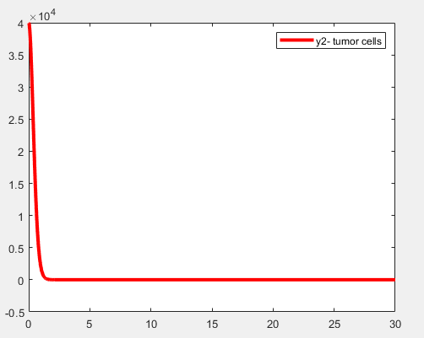

Figure B: Tumour Cells plot (MATLAB)

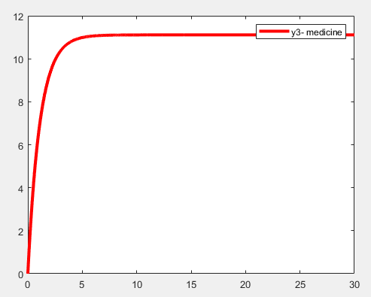

Figure C: Medicine plot (MATLAB)

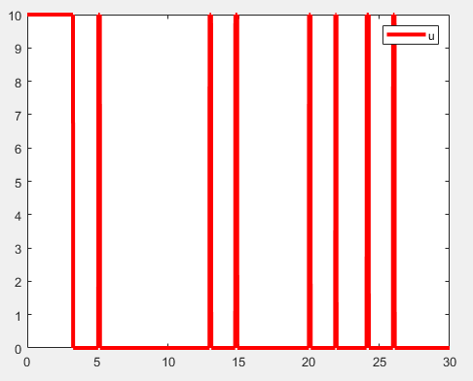

Figure D: Infinite Order Singular Arc U plot (MATLAB)

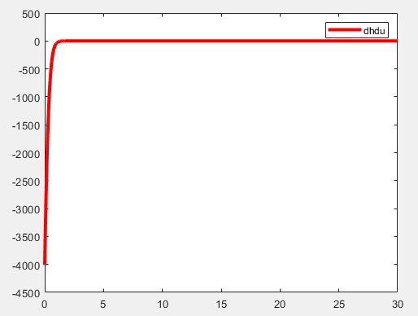

Figure E: Dh/du plot (MATLAB)

PART B

1. **Determine the weights (w1 and w2) when singular arc appears?**

As have been said in part a, when W1= 0.000001 and W2 =1-W1=0.999999, the discrepancy issue between Matlab results and AMPL results has been solved.

In this case, the value of the objective function in AMPL file= $1.9415x{10}^{4}$ and the objective function in Matlab file= $1.9415x{10}^{4}$.

Then the singular ARC could be viewed from Figure 1, where it is evident that it is an infinite order singular Arc input control.

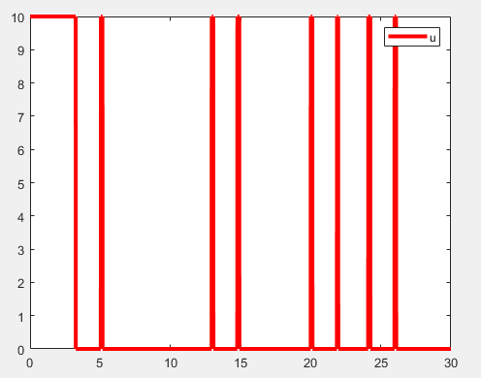

**Figure 1:** Singular Arc (U plot)

1. **Based on 4.), formulate the singular arc input control, Vm and thus apply the condition in Matlab simulation.**

**Figure 2:** Excel plot for U from AMPL file

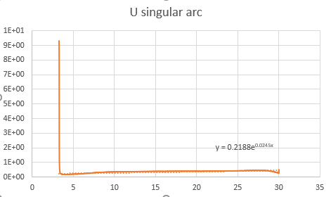

**Figure 3:** deriving the singular Arc equation

As could be seen from Figure 3, the equation of the singular arc has been extracted using the best fit line method. The equation is $U_{singular Arc}=0.2188e^{0.0245t}$

1. **If state constraints of E>10000 is imposed on the model, by using Matlab (Simulate in AMPL first as reference)**
2. **Determine the time, t1 when E hits boundary (E hits 10k).**

**Figure 3.1.1:** Excel plot for E from AMPL file



**Figure 3.1.2:** excel file t1

From figure 3.1.1 and figure 3.1.2, we can see that the time it hits the boundary of E<10K is at t1=0.81.

Or it could be gotten by capturing the time at which the Effector cells get into the boundary (become less than 10K) as shown in the Figure below

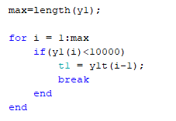’

**Figure 3.1.3:** capturing t1

1. **Develop the input control, u boundary to prevent E becoming less than 10k.**

|  |  |
| --- | --- |
| Equation |  |
| State constraint | S(x)= 10000-E $≤0$ |
| Set $\frac{ds}{dt}=0$ | |
| $$\frac{ds}{dt}$$ | $$\frac{ds}{dt}=-\frac{dE}{dt}=-s+μE-p\frac{ET}{h+T}+mET+K_{E}ME=0$$ |
| Second derivative of $\frac{dE}{dt} over time$ | |
| $$\frac{d^{2}E}{dt^{2}}$$ | $$\frac{d^{2}E}{dt^{2}}= \\ -μ\dot{E}+\frac{(h+T)(P\dot{E}T+PE\dot{T)-PET\dot{T}}}{{\left(h+T\right)}^{2}}-mT\dot{E}-mE\dot{T}-K_{E}M\dot{E}-\dot{M}K_{E}E$$ |
| Set $\frac{d^{2}s}{dt^{2}}=0$ | |
| $$\frac{d^{2}s}{dt^{2}}$$ | $$\frac{d^{2}s}{dt^{2}}=-\frac{d^{2}E}{dt^{2}}= \\ μ\dot{E}-\frac{(h+T)(P\dot{E}T+PE\dot{T)-PET\dot{T}}}{{\left(h+T\right)}^{2}}+mT\dot{E}+mE\dot{T}+K_{E}M\dot{E}+\dot{M}K_{E}E=0$$ |
| Get u boundary value | |
| U boundary | At this point, the new u boundary is assumed to be between Umin and Umax. It should be noted that at this boundary, Dh/du is assumed to be zero. Thus, the new boundary is assumed to be 1.7 |

The equation for U is

U $\left\{ \begin{aligned} Umax \frac{Dh}{Du}<0 \\ 0.2188e^{0.245t} \frac{Dh}{du}=0 \\ Umin \frac{Dh}{Du}>0 \end{aligned}\right.$

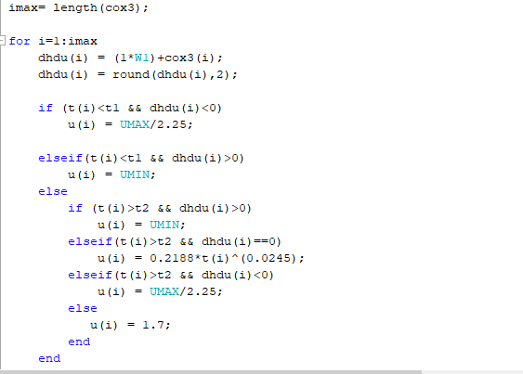

**Figure 3.2.1:** input control equation

1. **Determine the Lagrange multiplier, η for the constraint**

|  |  |
| --- | --- |
| Equation |  |
| State constraint | S(x)= 10000-E $≤0$ |
| Now the second thing after creating the state constraint is we insert it into the L function | |
| Langragian | $$L = H+μg+ηf where g=0$$ $$L = H+ηf$$ |
| L= ${(w1)V}_{m}+(w2)T+λ_{1}\left(s-μE+p\frac{ET}{h+T}-mET-K_{E}ME \right)+{ λ}_{2}\left(rT\left(1-bT\right)-a\frac{ET}{T+g}-K_{T}MT\right)+λ_{3}\left(-γM+{ V}_{M}\left(t\right)\right)+η(10000-E)$ |
| Now we find the stationary function Dh/du | |
| $$L_{u}=\frac{DL}{du}$$ | L= $w1+λ_{3}$ |
| Derive the costate functions | |
| $${\dot{λ}}_{E}=-\frac{DL}{dE}$$ | $$\left(μλ_{1}-p\frac{T}{h+T}λ_{1}+mTλ_{1}+K_{E}Mλ_{1} \right)+{ λ}_{2}\left(a\frac{T}{T+g}\right)+η$$ |
| $${\dot{λ}}_{T}=\frac{-DL}{dT}$$ | $$-(w2)+\left(-p\frac{Eh}{h+T}λ_{1}+mEλ_{1}\right)+\left({ - λ}_{2}r+{ 2rTbλ}_{2}-a\frac{Eg}{T+g}{ λ}_{2}+K_{T}M{ λ}_{2}\right)$$ |
| $${\dot{λ}}_{M}=\frac{-DL}{dM}$$ | $$λ_{1}\left(K_{E}ME \right)+{ λ}_{2}\left(K_{T}MT\right)+λ_{3}\left(γM\right)$$ |
| Get the $η langragian multiplier$ from the costates | |
| $${\dot{λ}}_{E}=0$$ | $$\left(μλ_{1}-p\frac{T}{h+T}λ_{1}+mTλ_{1}+K_{E}Mλ_{1} \right)+{ λ}_{2}\left(a\frac{T}{T+g}\right)+η=0$$ |
| $$η$$ | $$\left(-μλ_{1}+p\frac{T}{h+T}λ_{1}-mTλ_{1}-K_{E}Mλ_{1} \right)-{ λ}_{2}\left(a\frac{T}{T+g}\right) >0$$ |

After deriving the equation for the langragian constraint, it is written in matlab as shown in Figure 3.3.1

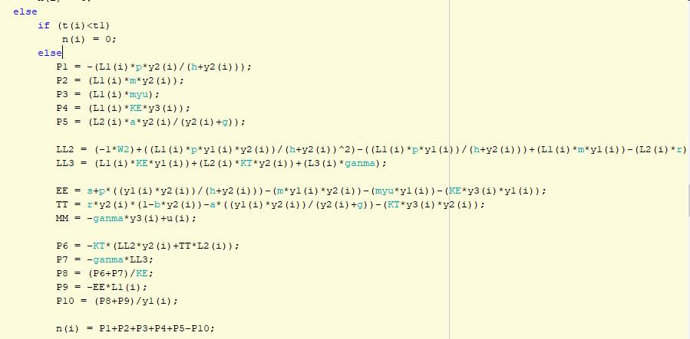

Figure 3.3.1: codes for Langragian Constraints

Where it should be as follows

$$η=\left\{\begin{aligned}\left(-μλ_{1}+p\frac{T}{h+T}λ_{1}-mTλ_{1}-K_{E}Mλ_{1} \right)-{ λ}_{2}\left(a\frac{T}{T+g}\right) t1<t<t2 \\ 0 otherwise \end{aligned}\right.$$

Thus, the plot of the langragian constraints are shown in the Figure below

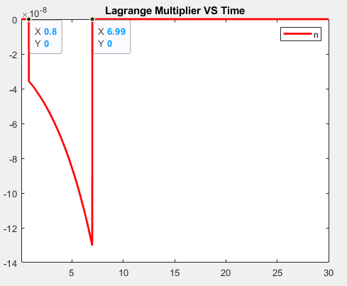

Figure 3.3.2 : langragian Constraint plot Matlab

Then write the constrained costate equations as shown in (Try costate constraints) function as seen in Figure 3.3.3

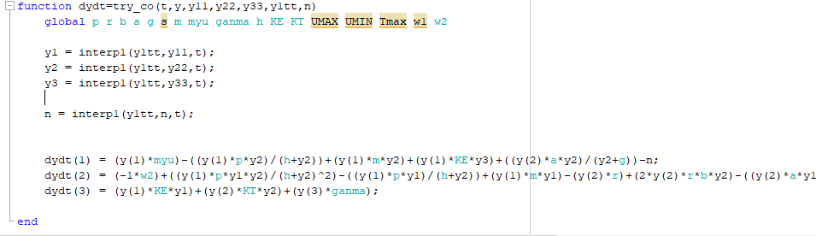

Figure 3.3.3: using the constraints in the costates

1. **Determine the time, t2 when E escapes from boundary (E at 10k).**

|  |  |
| --- | --- |
| Get the time | |
| S_arc function | The time at which it hits 10K is t1=0.81  You need to know the t2 (the time at which it escapes the boundary)  You use the costate and set v= $\frac{Dh}{du}$ Capture the time when v is very small [approaching zero], as shown in Figure below    Figure 3.4.1: capturing t2  The time at which it escapes the boundary is t2=6.98. |

1. **Proof the switching function is zero during boundary arc.**

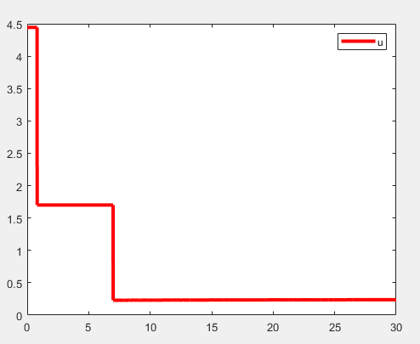

**Figure 3.5.1:** input control U plot (Matlab)

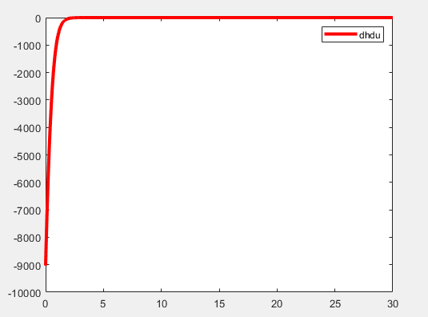

**Figure 3.5.2**: Dh/du plot (Matlab)

From the plots shown above, it could be seen that when the u is at the boundary arc value of 1.7, the value of the switching equation is dh/du=0.

1. **Show the results of effector cells, tumor cells and drug concentration against time, t for the constrained Effector cells.**

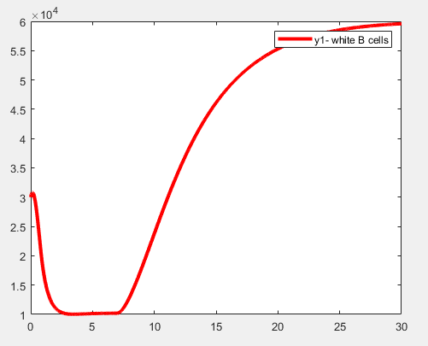

**Figure 4.1:** constrained effector cell against time (matlab)

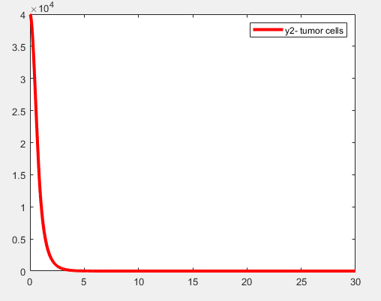

**Figure 4.2:** constrained tumour cell plot against time (matlab)

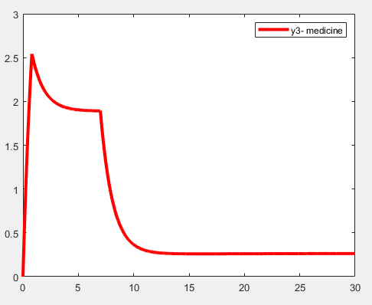

**Figure 4.3:** constrained drug concentration plot against time

**Figure 4.4:** constrained effector cell against time (excel)

**Figure 4.5:** constrained tumour cell plot against time (excel)

**Figure 4.3:** constrained drug concentration plot against time(excel)

From the three plots shown in this section, it could be seen that the discrepancy between the AMPL file and the matlab simulations have decreased quite significantly.

Additionally, the constraining of the effector cells has been successfully implemented in preventing the cells from becoming less than 10K.

However, it should be noted that the objective function J= 30605, which is higher than the AMPL file value.